La Prison, à Chichen-Itza
Désiré Charnay | ca. 1857–89 | Record IMG-MAM0009

1. Original Image
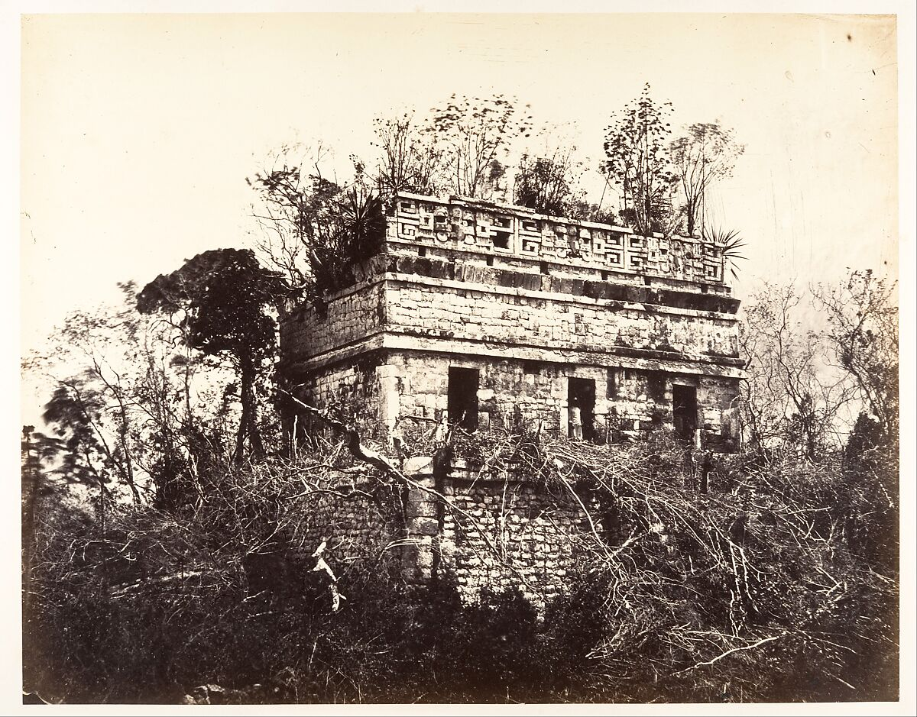
IMG-MAM0009. Désiré Charnay (French, 1828–1915), La Prison, à Chichen-Itza, 1857–89, Albumen silver print from glass negative, Image: 33.3 x 42.4 cm (13 1/8 x 16 11/16 in.), Mount: 54 x 70.8 cm (21 1/4 x 27 7/8 in.). The Metropolitan Museum of Art.

2. Record Summary
Record ID | IMG-NAM0008
Original title | La Prison, à Chichen-Itza
English title | The Prison, at Chichén Itzá
Alternative title | The building is now commonly identified as Casa Colorada or Chichanchob; its original function is uncertain
Creator | Désiré Charnay
Creation date | ca. 1857–89
Country | Mexico
Cultural region | Mesoamerica; Yucatán
Historical period | Nineteenth-century archaeological photography; ancient Maya subject
Image type | Photography
Medium | Albumen silver print from glass negative
Dimensions | Image: 33.3 × 42.4 cm; mount: 54 × 70.8 cm
Primary subject | Rectangular stone building
Secondary subjects | Doorways, vegetation, trees and two small figures
Source institution | The Metropolitan Museum of Art
Collection or object number (optional) | 2005.100.565

3. Image Description

3.1 Short Description
A rectangular stone building stands amid dense vegetation. Three dark doorways open across the lower façade, while a decorated horizontal band and low upper structure rise above. Trees partly obscure the building, and two small standing figures provide scale.

3.2 Detailed Visual Description
The lower façade is built from irregular stone blocks and contains three dark rectangular openings. Above them, a lighter band carries repeated geometric ornament. Bushes and grasses partially conceal the base of the building, while tall trees rise around and behind it.
Two small human figures stand near the front of the structure. Their clothing and identities cannot be described reliably because of distance. The pale sky contrasts with dark vegetation and doorways. The composition records the building within surrounding overgrowth rather than isolating it as a clean architectural specimen.

4. Formal Features
Field | Analysis
Composition | Centred horizontal façade framed by vegetation.
Viewpoint or camera angle | Ground-level frontal view.
Shot scale | Wide architectural view.
Spatial depth | Foreground plants, façade and background trees.
Lighting | Bright daylight.
Colour palette | Brown, black and cream monochrome.
Contrast | Strong contrast among sky, stone, vegetation and openings.
Visual focus | Decorated upper façade.
Texture | Masonry, carved ornament and dense foliage.
Movement or stillness | Static scene.
Medium-specific features | Sharp architectural details from a glass negative.

5. Historical Context and Purpose

5.1 Historical Context
Charnay was among the first photographers to document Maya ruins in Mexico. The Met retains his historical title, “La Prison,” but explains that the structure is now known as Casa Colorada or Chichanchob. Archaeologists remain uncertain about its original function and have proposed that it may have been an elite residence rather than a prison. [IMG-MAM0009-S01] Image Purpose and Circulation

5.2 Image Purpose and Circulation
Probable purpose: Archaeological and travel documentation intended to record and circulate views of Maya architecture.
Current institutional use: Interpretation of nineteenth-century archaeological photography while correcting the certainty implied by the older title.

